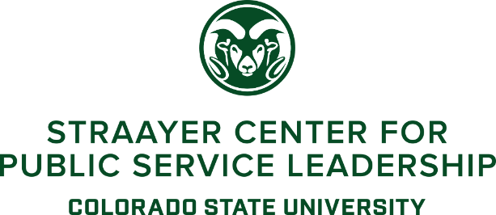

CSU Semester in Washington, D.C. Application for Fall 2019 Internship

Program Outline: Students will be selected from a competitive application process to enroll in 15 credit hours and participate in a semester-long internship experience in Washington, D.C. Students from all departments and majors at CSU are eligible to apply. Students will have the opportunity to complete an internship with an entity pre-selected based on student interest and will be responsible for fulfilling all requirements in conjunction with CSU and with The Washington Center. Full details are available from the Straayer Center for Public Service Leadership in Clark C338 or contact Sam Houghteling at sam.houghteling@colostate.edu.
Section I: Please provide all of the following information.
- Name, Student ID#:
- Major, Year in your Current Program:
- GPA (Unofficial transcript upon request):
Section II: Please attach all of the following materials.
- Professional/Academic Resume. No more than 2 pages.
- Attached at least 1-3 Professional Recommendations. One letter must be completed by an administrator or faculty member at CSU.
- Include a Statement of Interest outlining your applicable experience that would be an asset to this program, specific internship interests and/or area of focus, and a statement of how this program will advance your professional goals. No more than 500 words.
Section III: Please initial below the following statement acknowledging that you have read and accepted the terms.
The Straayer Center and other participating entities reserve the right to hold interviews with applicants between April 2-8, 2019. Applicants in consideration will be notified by the Straayer Center with their interview time and location. Notifications of acceptance will be sent out no later than April 10th, 2019.
Section IV: Please provide the name of your emergency contact, their relationship to you, their email, and their phone number.
Section V: Please respond to the following prompt in 500 to 750 words.
Outline a key issue related to your professional field, the primary actors involved, and how the institutions in Washington, D.C. could address that issue.

